Dear Parents
Soon it will be Father’s Day - Sunday 18th June - and we have decided to do something special via the school to surprise all the Dads, Grandads and special loved ones this year, whilst also raising money for the School/PTA! The gifts are unique as they are personalised by your child...... You simply need to ask your child to complete their special design in the box below (in felt-tip pens, coloured pencils or water-based paint only please) – then choose the gifts and complete the order form, returning to the school office with your money on: Monday 22nd May. All gifts will be sent home with your child in good time for Father’s Day!
Child’s Name: |  | 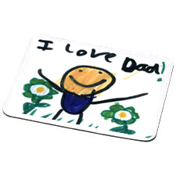  Class:
Teddies with personalised T-Shirt (Plush teddy, 9” Seated, t-shirt printed with design) | £6.99 each (School receives £1.50) | Qty ____ @ £6.99 = £_______
Personalised Mug & Chocolates (10oz White Ceramic Mug, boxed) | £6.99 each (School receives £2.00) | Qty ____ @ £6.99 = £_______
Personalised Mouse Mat (fabric top layer and thick rubber backing) | £5.50 each (School receives £1.00) | Qty ____ @ £5.50 = £_______
Please make cheques payable to: |  | Total Amount £ ___________
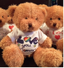

Teddies
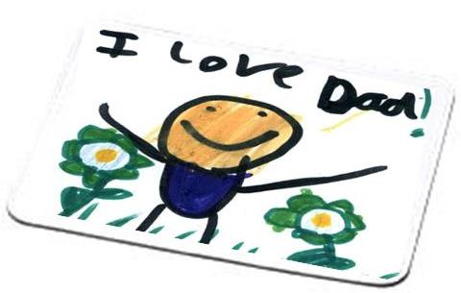
Mousemats

Mugs

www.schoolfundraisingcompany.co.uk
info@schoolfundraisingcompany.co.uk

